**Date 27/Sep/24**

**Afnan Tariq 29220**

**Eye Diseases**

**What is Epiretinal Membrane?**

An epiretinal membrane is a disease of the eye that involves the formation of an abnormal, thin membrane over the part of the eye called the macula. For this reason, an epiretinal membrane is often referred to as a macular pucker or scar across the central retina. [[1]](https://www.shinagawa.com.sg/news-resources/epiretinal-membranes-symptoms-causes)

If you think of your eye as a camera, the retina is like the photographic film. It is a very thin layer of tissue, which is sensitive to the image focused on it, and sends information to the brain. At the very centre of the retina is the macula. This is a very special area of the retina, which we use for reading and recognising complex shapes. Sometimes, scar tissue forms which grows across the macula. As the membrane contracts, it causes distortion of the retinal tissue. If this happens, the macula cannot work normally. [[2]](https://www.moorfields.nhs.uk/eye-conditions/epiretinal-membrane)

Since the disease affects the macula the part of the retina responsible for sharp vision this can have serious effects, as you’ll see below. [[3]](https://www.shinagawa.com.sg/news-resources/epiretinal-membranes-symptoms-causes)

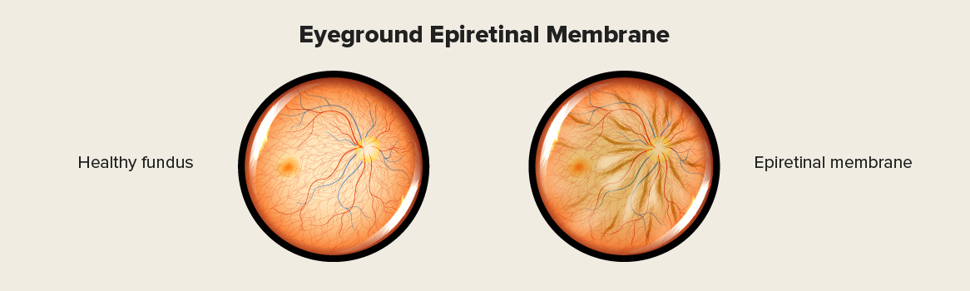

## ****Symptoms of Epiretinal Membranes****

* Loss of central vision
* Blurred or distorted vision
* Problems in reading or recognizing faces
* Straight lines start to appear wavy
* Double vision

There are also people whose epiretinal membranes cause issues. Common symptoms include blurring of central vision or distortion of images in that eye. This means that the affected person may see shapes that are normally straight, become noticeably crooked or wavy with this distortion.

It is worth noting that some of the symptoms of this condition are very similar to symptoms of other ocular diseases. Cataracts can produce similar symptoms, for example. A proper diagnosis can only come from an experienced eye doctor.

It is possible for epiretinal membrane to not cause any symptoms. A good number of people have asymptomatic epiretinal membranes that also never get worse, in which case they are left alone. [[4]](https://www.shinagawa.com.sg/news-resources/epiretinal-membranes-symptoms-causes)

**Causes of Epiretinal Membranes.**

In the majority of cases, **Epiretinal Membranes** happen as a part of the normal aging process in which changes occur inside the eye. It is common in people who are over the age of 50.

Epiretinal membranes are more likely in patients with certain conditions. These include prior retinal tears, diabetic retinopathy, and diseases affecting the vasculature of the retina.

An unnoticed injury or inflammation in the past, or the natural movement of the vitreous gel within the eye (known as vitreous detachment), can be potential causes of epiretinal membranes (ERMs). These conditions may lead to the development of a thin layer of scar tissue on the retina, which can affect vision. [[5]](https://youtu.be/zq7rMakO2iM?si=8-pp9GLmE8-NSZ9S)

Epiretinal membranes are associated with other retinal problems. [[6]](https://www.webmd.com/eye-health/what-is-epiretinal-membrane)

These conditions can include

* Diabetic retinopathy
* Ocular inflammatory disease
* Trauma
* Eye surgery
* Eye tumors
* Retinal tears
* Retinal detachment

**How Is an Epiretinal Membrane Diagnosed?**

Most of the time, people don’t know that they have an epiretinal membrane until it’s observed during a standard eye exam. Your eye doctor will base their diagnosis on your medical history and the results of a clinical exam. Sometimes, a technique called optical coherence tomography (OCT) can help with the diagnosis and determine how severe the condition is.

[Ocular Coherence Tomography (OCT)](http://www.asrs.org/patients/retinal-diseases/10/glossary#OCT)is an important imaging method used to assess the severity of the ERM.

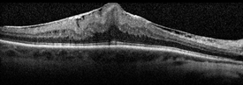

Epiretinal Membrane (OCT).

**What Are Epiretinal Membrane Treatments?**

If your epiretinal membrane isn’t causing any visual complications, then you don’t need immediate treatment. On the other hand, if you’re experiencing visual problems, then the best treatment is epiretinal membrane [surgery](https://www.webmd.com/eye-health/what-is-vitrectomy). The formal name for this surgery is a vitrectomy. [[7]](https://www.webmd.com/eye-health/what-is-epiretinal-membrane)

There are no eye drops, medications or nutritional supplements to treat ERMs. A surgical procedure called vitrectomy is the only option in eyes that require treatment. With vitrectomy, small incisions are placed in the white part of the eye, and the vitreous gel filling the inside of the eye is replaced with saline. This allows access to the surface of the retina where the ERM can be removed with delicate forceps, thereby allowing the macula to relax and become less wrinkled. Visual recovery is slow and most eyes experience improvement within 3 months but it may take a year to attain maximal visual acuity improvement.[[8]](https://www.asrs.org/patients/retinal-diseases/19/epiretinal-membranes#:~:text=There%20are%20no%20eye%20drops,eye%20is%20replaced%20with%20saline.)